**Frank Sharpe**

Student ID: 39222594

Assessment 2 Report

Back-end Development

# Contents

Contents 2

Table Of Figures 3

Introduction 4

Documentation 5

Home Page 5

Pupil 6

New 8

8

Reflection on Website 9

References 11

# Table Of Figures

Figure 1: ER Diagram 4

Figure 2 : Home Page 5

Figure 3 : Home.html 5

Figure 4 : home.html 5

Figure 5 : home.html 6

Figure 6 : Pupil home 6

Figure 7 : pupil home.html 7

Figure 8 : pupil.html 8

Figure 9: School Database 10

<https://github.com/franksharpe/St-Alphonsus-Primary-School>

# Introduction

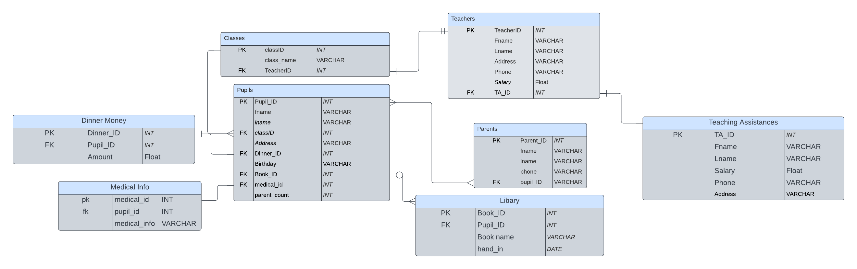Working as a back-end web developer for a primary school called St Alphonsus primary school they would like to change from paper based to online to automatize the process. With this technology available is coding language like html, CSS and JavaScript that have been adapted from other areas there is also PHP coding language and with use of MySQL you can create online databases. PHP is very useful coding langue “PHP is also known for its adaptability” this is useful as will help the project out (scaler , 2023). The school have 7 years of classes and have capacity’s and other rules to abide by.

Figure 1: ER Diagram

# Documentation

## Home Page

The home page main feature uses radio buttons this was achieved by as shown below setting the input type as radio.

Figure 2 : Home Page

Figure 3 : Home.html

Figure 4 : home.html

Java script was used to update the radio buttons to send to another webpage based upon one selected this code was useful and used throughout because of its simplicity.

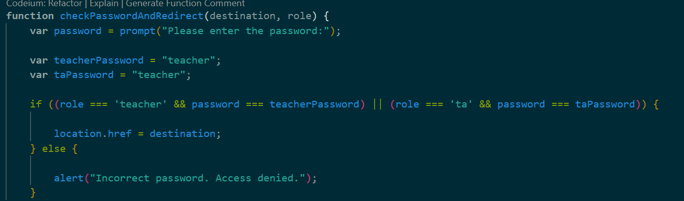

Figure : home.html

This simple front end validation to make sure the radio button “Teacher” and “Teaching Assistant” stays away from all users is a useful too for a school as sensitive and private websites would not be available to students.

## Pupil

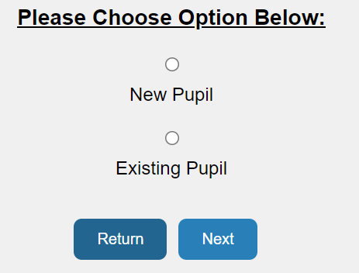

Figure 6 : Pupil home

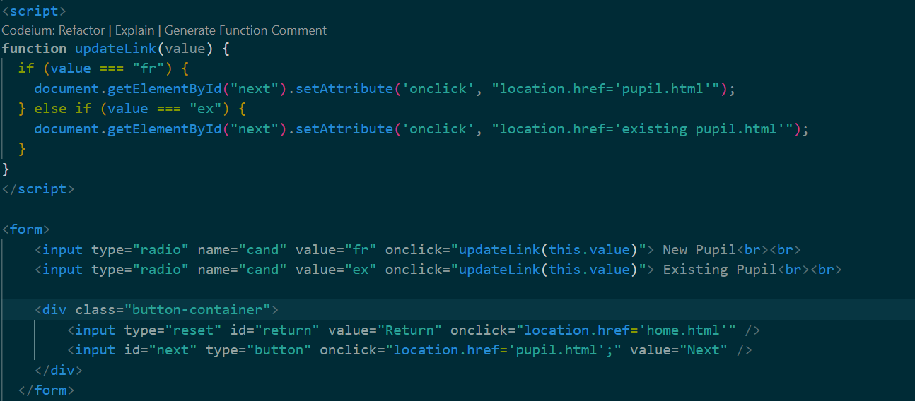

Figure 7 : pupil home.html

Simple code was used like in last page to complete the page. Using radio button types and simple JavaScript , this page takes you to existing or new pupils depending on which one the user is.

### New

Figure : pupil.html

Figure : pupil.html

The HTML form was created using tags such as text and select this is used to capture the users input it then passes through my JavaScript validation for front end data cleaning.

Figure : pupil.html

Figure : pupil.html

This validation checks to make sure that a class is selected.

Figure pupil.html

This validation checks the age based upon the birthday entered vs the year right now and then it checks that against the selected class to make sure the age is what is supposed to be in that class.



Figure : pupil.html

Once the form is submitted and validated it goes off to the php page which can send to the server

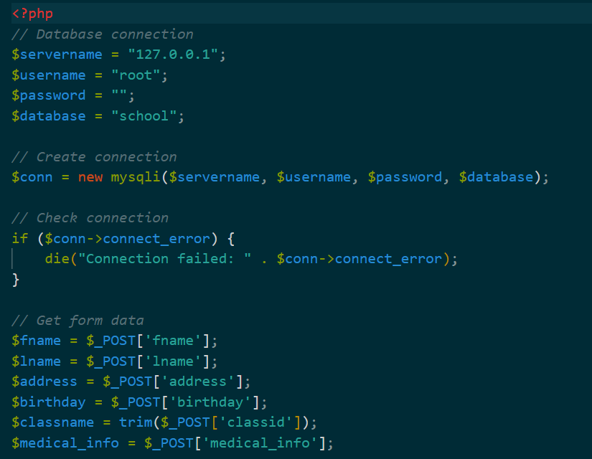

Figure : schooldb.php

Figure 15 : schooldb.php

Figure 14 will collect the form data and then it submits it into the database using figure 15 the SQL queries are what handles the data being inserted

# Reflection on Website

Technologies used For backend are coding languages like PHP and MYSQL these are very useful as “Open-source server-side programming languages like PHP and MySQL are used to make dynamic webpages” (Noble Desktop, ND) . dynamic webpages give seamless transition to the front end to the backend it is also a very popular language, “43.2% of websites on the internet are powered by WordPress, which uses it” (TurnKey Tech Staffing, 2023).So the project being written in PHP is very useful, this means that info from my forms go straight to my backend and the opposite works too when bring up the view in tables. It’s so seamless and quick as shown below.



Figure 16: School Database

Being able to get query up quickly is very useful for large databases as it means user experience is better. Websites that buffer and are slow Research indicates that even a brief delay of a few seconds can considerably raise the bounce rate (AIContentfy team, 2023). This could mean that users will get unhappy and not want to visit the website causing business or shop websites to lose business and St Alphonsus primary school project will make parents unhappy if it was slow.

“Oracle needs a licence cost, however MySQL is an open-source database option that is free” ( Dearmer, 2023). It being free means that the School can keep the budget down and save more money. As many schools don’t have a big budget paying for a service like oracle could mean many teachers get a pay decrease or budget cuts elsewhere. The other coding langue is Microsoft SQL server the first reason is “Platform Support: MS SQL Server is primarily made for the Windows environment, but MySQL is platform-independent and can run on a variety of operating systems” and also “Licensing and Pricing: MySQL is an open-source database, generally free to use, while MS SQL Server is a commercial product with a variety of licensing options” (Jeremy, 2023) . Being able to operate on many systems mean a seamless transition if the school don’t have any windows operating system running computers, and also same as before licensing can mean that you end up causing budget problems as it cost to build and run.

Word count: 486

# References

Scaler. (2023). Advantages of PHP. [online] Available at: <https://www.scaler.com/topics/php-tutorial/advantages-of-php/>

Aicontentfy. (2023). Impact of Website Speed on Customer Acquisition. [online] Available at: <https://aicontentfy.com/en/blog/impact-of-website-speed-on-customer-acquisition#:~:text=A%20slow%2Dloading%20website%20can%20have%20a%20major%20impact%20on,for%20a%20page%20to%20load>.

Turnkey Labs. (2023). Is PHP Dead? At Least According to Usage Statistics. [online] Available at: <https://www.linkedin.com/pulse/php-dead-least-according-usage-statistics-turnkey-labs/>

Noble Desktop. (n.d.). Why Learn PHP MySQL? [online] Available at: <https://www.nobledesktop.com/learn/php-mysql/why-learn-php-mysql#:~:text=PHP%20and%20MySQL%20are%20open%2Dsource%20server%2Dside%20programming%20languages,slow%20internet%20and%20data%20speed>.

Integrate.io. (2023). Oracle vs MySQL. [online] Available at: <https://www.integrate.io/blog/oracle-vs-mysql/#:~:text=Oracle%20supports%20distributed%20databases%20while,Oracle%20requires%20a%20licensing%20fee>.

DreamFactory. (2023). MS SQL Server vs MySQL. [online] Available at: <https://blog.dreamfactory.com/ms-sql-server-vs-mysql/#:~:text=The%20main%20difference%20between%20MySQL%20and%20MS%20SQL%20are%3A,a%20variety%20of%20licensing%20options>.